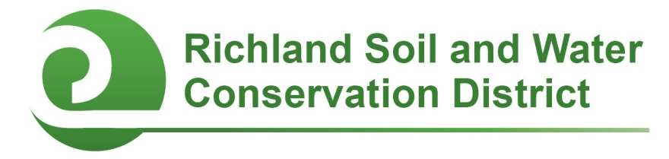
2014-2015 Conservation Education Mini-Grants
Application Form

Criteria, Eligibility, and Timeline: Faculty and staff members of public, private, and alternative schools in Richland County are eligible to apply for this mini-grant (up to $250) for campus conservation projects and youth environmental education initiatives. Two award cycles are available: applications received by October 15, 2014 will be considered for fall 2014 funding; applications received by February 13, 2015 will be considered for spring 2015 funding. Project work and the expenditure of funds must be completed by June 30, 2015.

Applicant’s name and title/position:

School:

E-mail address: Phone #:

Principal’s Name:

Principal’s Signature: ______________________________________________

- Project Overview: Describe the proposed project and how it promotes natural resource conservation and education.

- Project Budget: Add additional rows if necessary.

Item | Unit Cost ($) | Quantity | Cost ($)
Total ($)

- Funding: If your project will cost more than $250 (the maximum amount of the mini-grant), how will the rest of the project be funded?

- Project timeline: Describe your project’s timeline.

- Student Involvement:
  - How many students will be involved with this project? List by grade.

  - How will students be involved with this project?

- Collaboration: Describe if and how other faculty members, staff, parents, project mentors, or community volunteers will be involved with the project.

- Educational Outcomes: How will this project enhance student learning? Please include specific state standards and indicators addressed by this project.

- Optional Supporting Materials: You are welcome but not required to submit photographs with captions, letters of support, or other materials demonstrating why your project deserves to receive an Earth Day Mini-Grant.

Send application and any optional supporting materials to:
Richland Soil and Water Conservation District
2020 Hampton Street, Room 3063A
Columbia, SC 29204
Fax: (803) 576-2088
E-mail: cooperc@rcgov.us
Phone: (803) 576-2080

